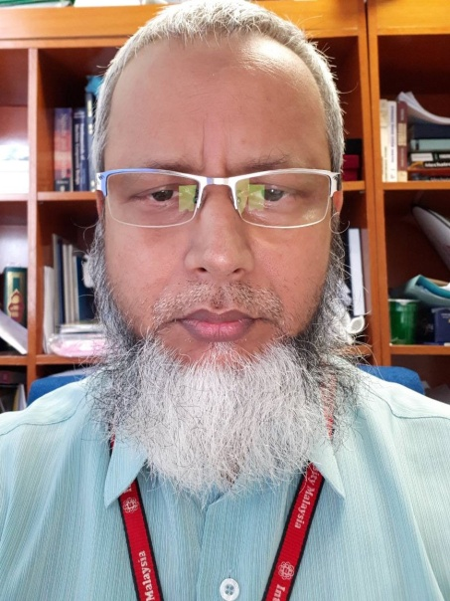
Biography
Md. Raisuddin Khan
Department of Mechatronics Engineering
International Islamic University Malaysia, Kuala Lumpur, Malaysia
Email: raisuddin@iium.edu.my

Professor Md. Raisuddin Khan received his B.Sc. degree in Mechanical Engineering from the former Engineering College, Rajshahi, Bangladesh [(currently known as Rajshahi University of Engineering and Technology (RUET)], in 1983. He received his M.Sc and Ph.D degrees in Mechanical Engineering from the Bangladesh University of Engineering and Technology (BUET) in 1988 and 1996 respectively. Currently he is a Professor in the department of Mechatronics Engineering of the International Islamic University Malaysia (IIUM). He has been serving the Mechatronics Engineering Department of IIUM for more than sixteen years. He has wide experience of designing and reviewing Mechatronics Engineering curriculum of different universities in Malaysia and overseas. He is the coordinator of the Autonomous Systems and Robotics Research Unit (ASRRU) of IIUM. His research interest covers robotics, smart devices, vibration and stress analyses of structures. He received several medals from different national and international exhibitions for innovating different Mechatronics products. He has so far published more than sixty papers in different international journals and conferences. He is life fellow of IEB and BSME, and Senior member of IEEE.

